WWII

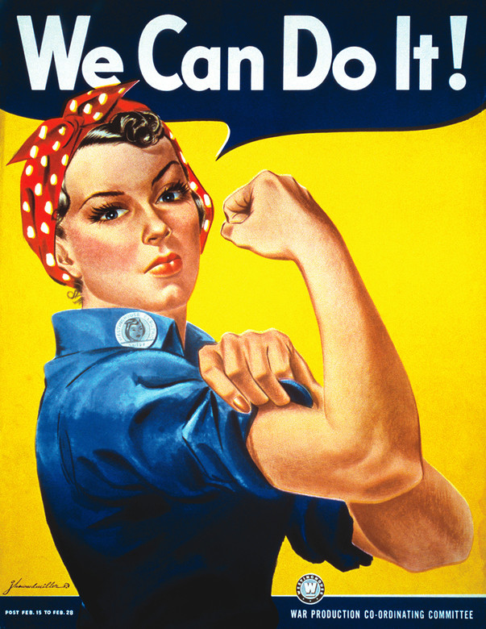

Name: ______________________________

**U.S. Enters World War II:**

**1. Watch the following video clip** <https://www.youtube.com/watch?v=SnWXSIy412I>

**2. Read the information below and then answer the questions that follow:**

The Attack on Pearl Harbor happened on December 7th, 1941. Japanese airplanes made a surprise attack on the US Navy in Pearl Harbor. They destroyed many ships and killed many soldiers. It was this attack that forced the United States to enter World War II.

**Where is Pearl Harbor?**

Pearl Harbor is located in Hawaii on the island of O'ahu. Hawaii is located in the Pacific Ocean between California and Japan. During the time of World War II, Hawaii was not a state, but a US territory.

**Before the Attack**

World War II had been raging in Europe and Asia for two years, but the United States had not entered the war. The Empire of Japan was trying to take over much of Asia and was worried about the US Navy in Hawaii. They decided to strike in order to prevent the United States from attacking them. The Japanese thought that if they took out the war ships in Pearl Harbor, then the United States Navy would be crippled and would never attack. However, they were mistaken and the attack on Pearl Harbor had just the opposite result. The US declared war the next day.

**The Attack**

The attack on Pearl Harbor came as a complete surprise. Hundreds of Japanese fighter planes and bombers flew to Pearl Harbor and attacked. The bombers dropped bombs and torpedoes on the war ships, while the fighter planes attacked the US fighter planes on the ground so they could not take off and fight back. There were two waves of attacks and by the end of the second wave a number of US ships were destroyed.

**After the Attack**

The citizens of the United States were in shock. They had tried to avoid the war, but they could not ignore this attack. The Japanese had hoped to break the Americans by attacking Pearl Harbor, instead they united them. The next day, December 8th, 1941, the US declared war on Japan. Three days later Japan's allies, Germany and Italy, declared war on the United States. The United States was now a major part of World War II. The US Navy was able to recover from the attack on Pearl Harbor fairly quickly. The Japanese had not damaged a number of important facilities on the Hawaiian Islands, including oil storage depots and repair yards. Also, no aircraft carriers were in Pearl Harbor at the time of the attack. Aircraft carriers would soon become the most important type of navy vessels in the war.

This text is Copyright © Ducksters.

What event made the U.S. enter WWII?

* After this event, who did they declare war on?
* When did this even take place?

**Watch the following video clip and answer the question below** <https://www.youtube.com/watch?v=YhtuMrMVJDk>

FDR’s famous quote about the attack on Pearl Harbor was “a date which will live in infamy.” What does this quote mean?

**U.S. on Home Front:**

**1. Watch the following video clip** <https://www.youtube.com/watch?v=9aRVVae2i_c>

**2. Read the following information and then answer the questions that follow**

Even though the fighting in World War II was all the way across the Atlantic and Pacific Oceans, the war changed the lives of everyone in America. The war effort in the United States was often called the home front.

**Rationing**  
  
Because of the war, many products were in short supply. Metal had to be used to make tanks and battle ships. Medicine was needed for the battlefields. Also, some products were hard to get as they came from countries that were at war. Rubber for tires was especially difficult to get because much of it was imported from Southeast Asia.  
  
By the end of the war, many products were rationed. Each family would get ration stamps allowing them to buy a certain amount of a type of product. Products rationed included tires, automobiles, sugar, gasoline, meat, butter, and coal.  
  
**War bonds** were a form of savings [bond](https://academickids.com/encyclopedia/index.php/Bond) used by many combatant nations to help fund [World War II](https://academickids.com/encyclopedia/index.php/World_War_II).

**Women go to work**  
  
When World War II began in 1939 there were around 190,000 men in the US Army. By the time the war ended in 1945, there were over 10 million. On top of this, factories in the US were at full capacity making arms, tanks, ships, and vehicles for the war. There was a shortage of workers.

To fill the gap and help build supplies for the war, many women went to work. They took on tough physical labor jobs that previously had been done mostly by men. Women who went to work in factories were nicknamed Rosie the Riveter. They played a major role in keeping the factories running smoothly and producing much needed planes, tanks, and other arms for the war.

**Entertainment and Propaganda**  
  
The US government knew that Americans must stay united in the war effort in order to win the war. They created all sorts of posters that showed patriotism and ways that people could help with the war effort from home. There were also lots of wartime movies showing how brave the soldiers were and how evil Hitler and the enemy was. All movie scripts had to be approved by the government.  
  
Many celebrities fought in the war. Baseball players such as Joe DiMaggio and Ted Williams enlisted and fought. Also movie stars such as Jimmy Stewart and Clark Gable joined the army. At one point the commissioner of Major League Baseball wrote a letter to President Roosevelt asking if professional baseball should continue during the war. Roosevelt responded that they should keep playing baseball because it was good for the country's moral.

This text is Copyright © Ducksters.

Why were war bonds important during WWII?

* Why was rationing important during WWII?

What was the name given to the posters that encouraged Americans to participate in the war?

**Holocaust/Internment Camps:**

**1. Watch the following video clips** <https://www.youtube.com/watch?v=4IJ4mpCDVpE> and <https://www.youtube.com/watch?v=OU-k0uG8pAw>

**2. Read the following information and then answer the questions that follow**

**Holocaust**

The Holocaust is one of the most terrible events in human history. It occurred during World War II when Hitler was leader of Germany. Six million Jewish people were murdered by the Nazis. This included as many as 1 million Jewish children. Millions of other people that Hitler didn't like were killed as well. This included Polish people, Catholics, Serbs, and handicapped people. It is thought that the Nazis murdered as many as 17 million innocent people.

**Why did Hitler and the Nazis do it?**  
  
Hitler hated Jewish people and blamed them for Germany losing World War I. He considered Jewish people to be less than human. Hitler also believed in the superiority of the Aryan race. He wanted to use Darwinism and breeding to create a race of perfect people.  
  
Hitler wrote in his book Mein Kampf that when he became ruler he would rid Germany of all the Jews. Not many people believed he would really do this, but as soon as he became Chancellor he started his work against the Jews. He made laws that said Jews had no rights. Then he organized attacks on Jewish businesses and homes. On November 9, 1938 many Jewish homes and businesses were burnt down or vandalized. This night was called the Kristallnacht or "Night of Broken Glass".

**Ghettos**  
  
During World War II when the Nazis would take over a city in Europe they would force all of the Jewish people into one area of town. This area was called a ghetto and was fenced in with barbed wire and guarded. There was little food, water, or medicine available. It was also very crowded with multiple families sometimes sharing a single room to live in.  
  
**Concentration Camps**  
  
All Jewish people were eventually to be brought to concentration camps. They were told they were relocating to a new and better place, but this was not the case. Concentration camps were like prison camps. People were forced to do hard labor. The weak were quickly killed or died of starvation. Some camps even had gas chambers. People would be led into the chambers in large groups only to be killed with poison gas. The concentration camps were horrible places. The largest concentration camp was location at Auschwitz   
  
**Hiding**  
  
Many Jewish people hid from the Nazis during World War II. They would hide with non-Jewish families. Sometimes they would pretend to be a part of the family and sometimes they would hide in hidden rooms or in a basement or attic. Some were able to eventually escape across the border into a free country, but many hid for years sometimes in the same room.

This text is Copyright © Ducksters.

Define **HOLOCAUST:**

Where was the largest concentration camp located at?

**Internment Camps:**

After the Japanese attacked Pearl Harbor the United States declared war on [Japan](https://www.ducksters.com/geography/country/japan_history_timeline.php) and entered World War II. Not long after the attack, on February 19, 1942, President Roosevelt signed an executive order that allowed the military to force people of Japanese ancestry into internment camps. Around 120,000 Japanese-Americans were sent to the camps.

**What were internment camps?**  
  
Internment camps were sort of like prisons. People were forced to move into an area that was surrounded by barbed wire. They were not allowed to leave.  
  
**Why did they make the camps?**  
  
The camps were made because people became paranoid that Japanese-Americans would help Japan against the United States after the Pearl Harbor attack. They were scared that they would sabotage American interests. However, this fear was not founded on any hard evidence. The people were put in the camps based only on their race. They had not done anything wrong.

**Who were sent to the internment camps?**  
  
It is estimated that around 120,000 Japanese-Americans were sent to ten camps spread out around the Western United States. Most of them were from west coast states like California. They were divided into three groups including the Issei (people who had immigrated from Japan), the Nisei (people whose parents were from Japan, but they were born in the U.S.), and the Sansei (third generation Japanese-Americans).

**Were there children in the camps?**  
  
Yes. Entire families were rounded up and sent to the camps. Around a third of the people in the camps were school aged children. Schools were set up in the camps for the children, but they were very crowded and lacked materials like books and desks.  
  
**What was it like in the camps?**  
  
Life in the camps wasn't very fun. Each family typically had a single room in tarpaper barracks. They ate bland food in large mess halls and had to share bathrooms with other families. They had little freedom

**The Internment Ends**  
  
The interment finally ended in January of 1945. Many of these families had been in the camps for over two years. Many of them lost their homes, farms, and other property while they were in the camps. They had to rebuild their lives.

**The Government Apologizes**  
  
In 1988, the U.S. government apologized for the internment camps. President Ronald Reagan signed a law that gave each of the survivors $20,000 in reparations. He also sent each survivor a signed apology.

This text is Copyright © Ducksters.

Define **INTERNMENT CAMPS:**

What group of people were held in Internment Camps?

What event in U.S. history places Japanese Americans in Internment Camps?

How are they similar to Concentration Camps?

How are they different from Concentration Camps?

**End of WWII:**

**1. Watch the following video clip** <https://www.youtube.com/watch?v=ncq_Wye43TM>

**2. Read the following information and then answer the questions that follow**

At the start of World War II in 1939 the atomic bomb had not yet been invented. However, scientists discovered about that time that a powerful explosion might be possible by splitting an atom. This type of bomb could destroy large cities in a single blast and would change warfare forever.

**Albert Einstein**  
  
[Albert Einstein](https://www.ducksters.com/biography/albert_einstein.php) came up with many of the theories that helped scientists in making the atomic bomb. When he realized that such a bomb could be made, he was frightened about what might happen if Hitler and Germany learned how to make the bomb first. He wrote a letter to US President Franklin Roosevelt telling him about the atom bomb. As a result, Roosevelt set up the Manhattan Project.  
  
**Manhattan Project**  
  
The Manhattan Project was the name for the research and development program for the atomic bomb. It started small, but as the bomb became more real, the United States added scientists and funding to be sure they were the first to have the bomb. Ironically, many of the scientists involved in making the bomb had defected from Germany. By the end of the project, funding had reached $2 billion and there were around 200,000 people working on the project.

**The First Atomic Bomb**  
  
On July 16, 1945 the first atomic bomb was exploded in the New Mexico desert. The explosion was massive and the equivalent to 18,000 tons of TNT. Scientists figured that the temperature at the center of the explosion was three times hotter than at the center of the sun.  
  
Although the scientists were happy they had successfully made the bomb, they also were sad and fearful. This bomb would change the world and could cause mass destruction and death. When President Harry Truman heard of the bomb's success he wrote "We have discovered the most terrible bomb in the history of the world".  
  
**Deciding to Drop the Bomb**  
  
By the time the first atomic bomb had been made, Germany had already surrendered and World War II in Europe was over. [Japan](https://www.ducksters.com/geography/country/japan.php) was defeated as well, but would not surrender. The US was contemplating an invasion of Japan. Army leaders figured that anywhere from 500,000 to 1 million US and Allied soldiers would die in an invasion. President Truman decided to drop the atomic bomb instead to save American lives and end the war quickly.

**Hiroshima**  
  
On August 6, 1945 an atomic bomb named Little Boy was dropped on Hiroshima, Japan. The explosion was huge, the city was destroyed, and tens of thousands of people were killed. The bomb was dropped by a plane named the Enola Gay which was piloted by Colonel Paul Tibbetts. The bomb itself was over 10 feet long and weighed around 10,000 pounds. A small parachute was on the bomb in order to slow its drop and allow the plane time to fly away from the blast zone.

**Nagasaki**  
  
Despite witnessing the terrible destruction of the bomb on Hiroshima, Emperor Hirohito and Japan still refused to surrender. Three days later, on August 9, 1945, another atomic bomb, nicknamed Fat Man, was dropped on Nagasaki, Japan. Again the devastation was horrible.  
  
**Surrender**  
  
Six days after the bombing of Nagasaki, Emperor Hirohito and Japan surrendered to US forces. The Emperor announced this on the radio. It was the first time most Japanese had heard his voice.

This text is Copyright © Ducksters

How did WWII end?

* + What were the two reasons it ended this way?

1.

2.

**Document Practice:**

## Document #1: Letter to Congress

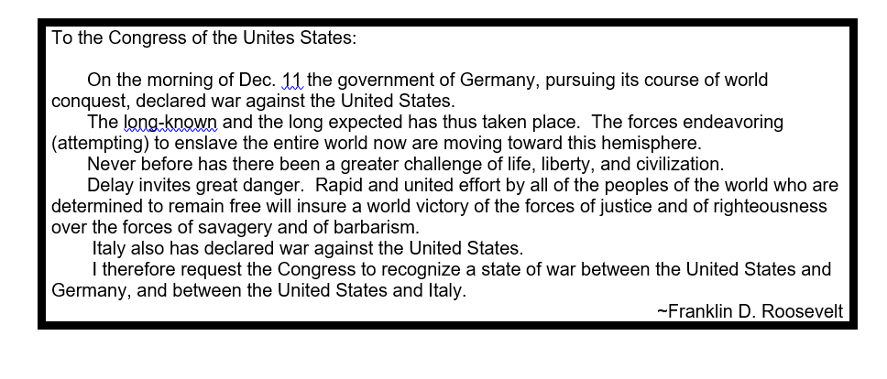

1. Why did FDR write this document to Congress?
2. According to the document, what was Germany’s goal?
3. According to the document, what did the free people of the world need to do to ensure victory?
4. How did Roosevelt describe the world forces compared to the German forces in this document?

## Document #2 Fireside Chat

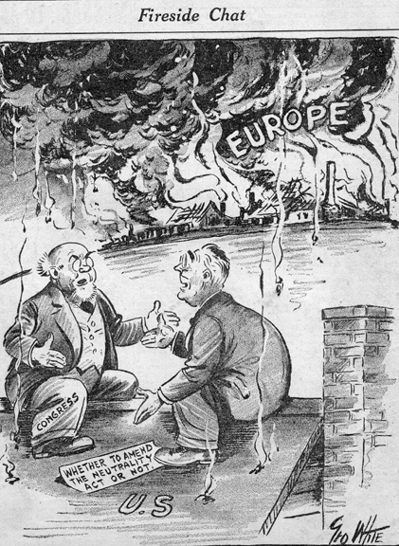

1. What did the roof symbolize in the cartoon?
2. Who did the two men in the cartoon represent?
3. What event was represented by the fire and smoke in Europe?
4. What were the two men discussing?

**Document #3: Western Union Telegram**

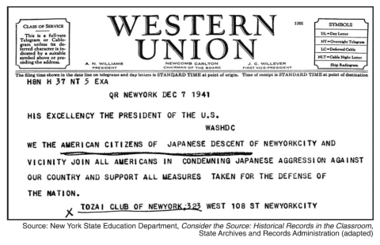

1. What group sent this telegram to the president?
2. To which United States president was this telegram sent?

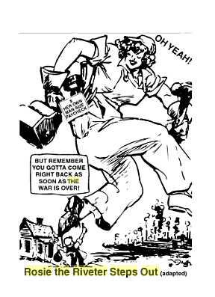**Document #4: Women in Factories**

1. What indicated the woman in the cartoon was going to work?
2. What could have been the woman’s job?
3. Why did the cartoonists draw the woman so large?
4. According to the cartoonist, what was expected to happen to the woman after the war?

**Document #5: WWII Posters**

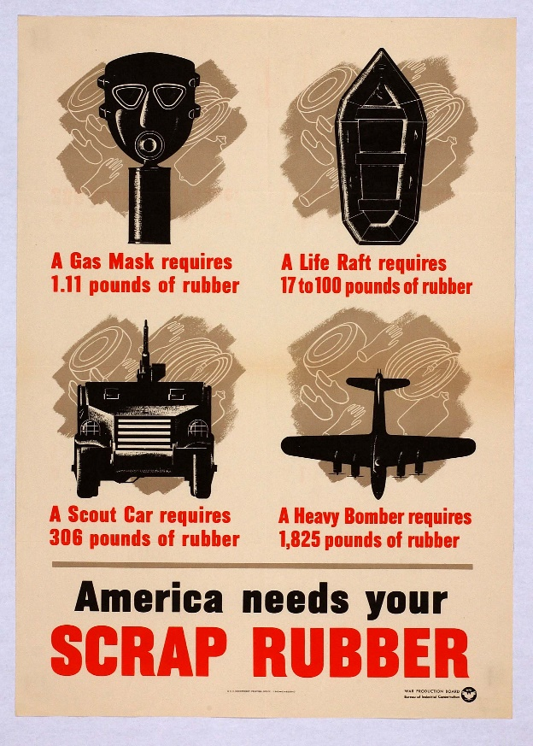

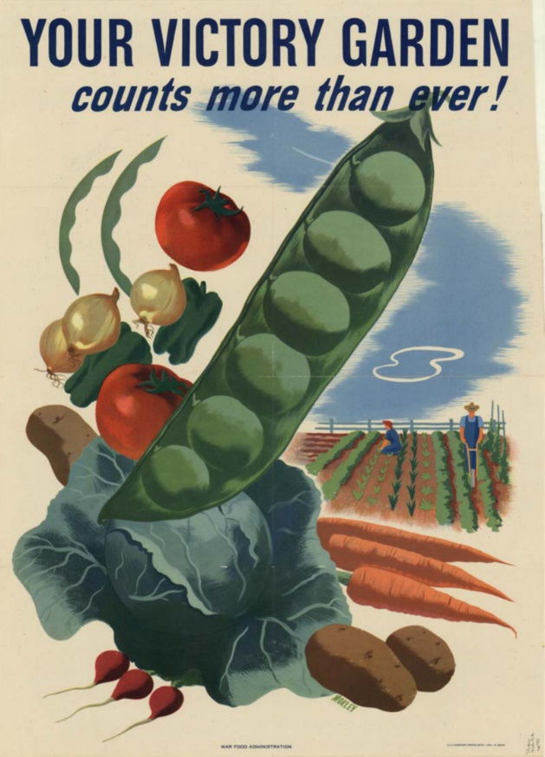

1. In what way do both of these posters encourage Americans to participate in the war effort?
2. How would this help American soldiers fighting in Europe or in the Pacific?